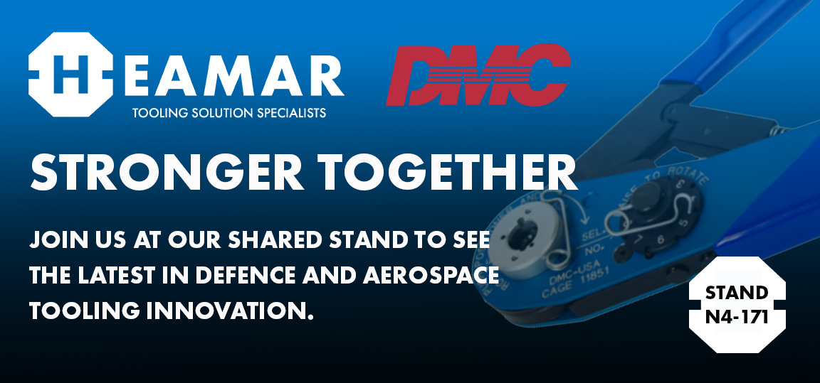

At DSEI 2025, Heamar will proudly share stands with Daniel Manufacturing Corporation (DMC), a partnership built on precision, trust, and shared commitment to raising the bar for mission-critical tooling solutions. Visitors to our stand will experience hands-on demonstrations of the latest DMC, Ingersoll Rand, Band-It, Ideal tools, which include intelligent systems engineered to improve safety, traceability, and performance in the most demanding operational environments.

**Stronger Together: Heamar x DMC**

Our joint presence with Daniel Manufacturing at DSEI is more than a shared stand, it’s a shared vision. By integrating DMC’s world-renowned electrical connector assembly tooling with our intelligent tool platforms and tailored service approach, we’re delivering complete, end-to-end solutions to engineers, technicians, and procurement teams across aerospace, defence, and high-reliability manufacturing.

**Making Things Easy, Making a Difference**

This showcase embodies Heamar’s commitment to making a **positive impact**, not only by delivering best-in-class products, but by taking the bull by the horns when it comes to solving complex challenges. We're not just exhibiting tools; we're enabling outcomes.

Stop by to explore how we’re delivering on our promise: to be a class act in every connection we create — from tool to technician, system to solution.